FOR OFFICE USE
Date Recv’d. Appl. Fee Cnsl. Assist. Appl. Ft. Sht.

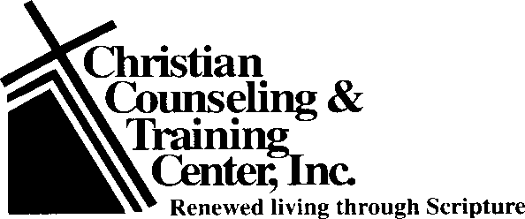
2510 Professional Road
North Chesterfield, VA 23235-3236
804.358.1343

Application for Biblical Counseling
PERSONAL INFORMATION (Confidential)
Name Phone Address Zip Code Occupation Business Phone Cell Phone
Sex Birth Date Age When is the best time to reach you by phone? Email address
Marital Status: Single Married Separated Divorced Widowed Education: (last year completed) (grade) Other training: (list type and years)

Referred here by Present church attending

Religious background of spouse (if married) Briefly explain your reason for seeking counsel at this time

HEALTH INFORMATION
List all important present or past illnesses or injuries or handicaps or surgeries

Are you presently taking medication? If yes, what? Have you used drugs for other than medical purposes?
What?
Have you ever had a severe emotional upset? Explain Have you ever had any psychotherapy or counseling before? If yes, list counselor or therapist and dates

What was the outcome?

AVAILABILITY (Please provide the hours available, i.e. 3:00 – 8:00 PM)
MONDAY | TUESDAY | WEDNESDAY | THURSDAY | FRIDAY

MARRIAGE AND FAMILY INFORMATION
Name of spouse Address Phone Occupation Business phone Spouse’s age Education (in years) Religion If spouse is involved in counseling, their reason for seeking counseling (To be filled out by spouse)

Rate Spouse’s health (Good, fair, poor, other) and list any pertinent medical information

Have you ever been separated? If so, when? From to Has either of you ever filed for divorce? If so, when? Date of marriage Ages when married: Husband Wife How long did you know your spouse before marriage? Length of dating with spouse Length of engagement Give brief information about any previous marriages

INFORMATION ABOUT CHILDREN: (Note: Each counselee is responsible for their own childcare)
Names Age Sex Living Part of Counseling (Yes No) (Yes No)

Have you, or your spouse, successfully completed Biblical Problem Solving or Building Biblical Relationships?

Y/N Year completed Teacher

My signature below indicates that I consent to allow note taking of any counseling sessions conducted by CCTC on my behalf. I understand that my case may be discussed with other counselors at CCTC, other professionals and/or my church leadership, but only to the degree necessary to find further Biblical solutions to the problems presented. I understand that any outside consultation will be discussed with me and will be conducted in accordance with the highest standards of Biblical ethics. I further agree not to hold CCTC liable for any malady, illness, and/or death, the cause of which may be attributable to the side effects of any prescription or medications which I am currently taking.
Signature of applicant (s): Date:
Complete this form and submit the $75.00 administrative fee. Payment can be made by check, completing form below, or at https://give.cornerstone.cc/cctcinccctcinc.org. The Counseling Coordinator will contact you to confirm the appointment.

You may pay your administrative/assessment fee via credit card, if you choose to do so complete the following:

MC/VS# Exp. Date: CardVV: Print name of cardholder:
Cardholder address: State: Zip Code: Signature of authorized user:

Revised 07/16/26 © Copyright 1989 Christian Counseling & Training Center, Inc.

